CS 255 System Design Document
Gage Pigati
Design Basis. This system design continues the DriverPass requirements established in Project One. The design uses a blended process and object approach so the workflows are clear while the system data and relationships are also organized for development.

UML Diagrams

UML Use Case Diagram
The use case diagram shows the main DriverPass users and the system functions they need. The approved Module Six design is retained as the foundation. It includes Customer, Secretary, Driver, Owner, IT Officer, and DMV System actors, along with lesson scheduling, training packages, practice tests, driver notes, activity reports, account the owner, package controls, and DMV update functions.
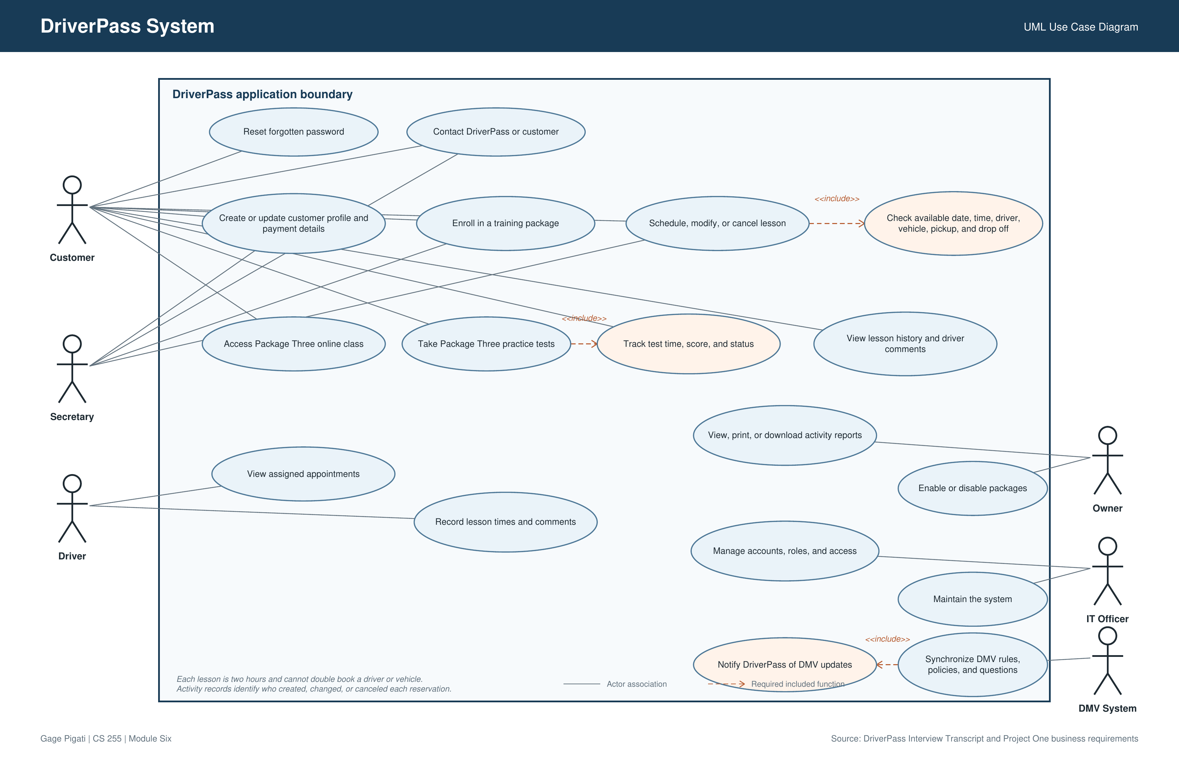
Figure 1. DriverPass UML use case diagram.

UML Activity Diagrams
The first activity diagram models lesson scheduling. It covers the customer or secretary request, package hour check, driver and vehicle availability, reservation creation, activity tracking, and the alternate path when the requested time is unavailable.
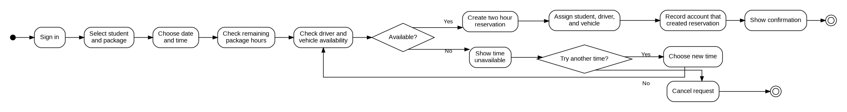
Figure 2. Schedule driving lesson activity diagram.
The second activity diagram models a Package Three practice exam. It shows access checking, test attempt status, question completion, scoring, and saving the test name, time taken, score, and final status.
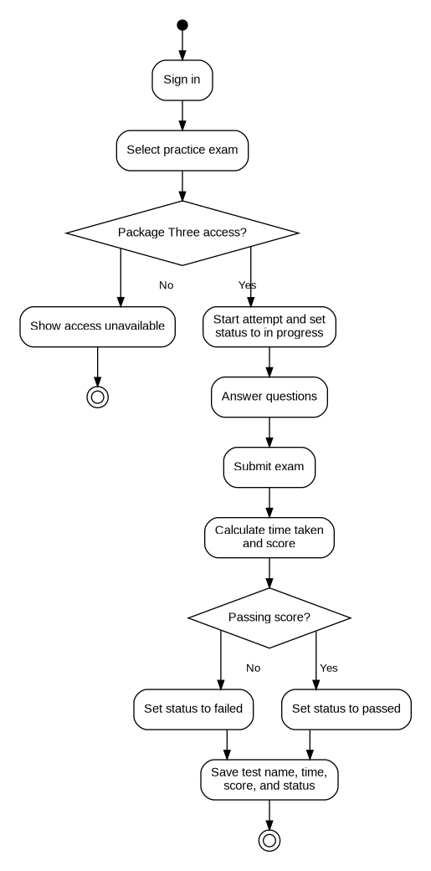
Figure 3. Take practice exam activity diagram.

UML Sequence Diagram
The sequence diagram uses the lesson scheduling use case to show how a customer or secretary interacts with the DriverPass web application, reservation logic, and centralized database. It also shows the alternate response when a requested time cannot be scheduled.
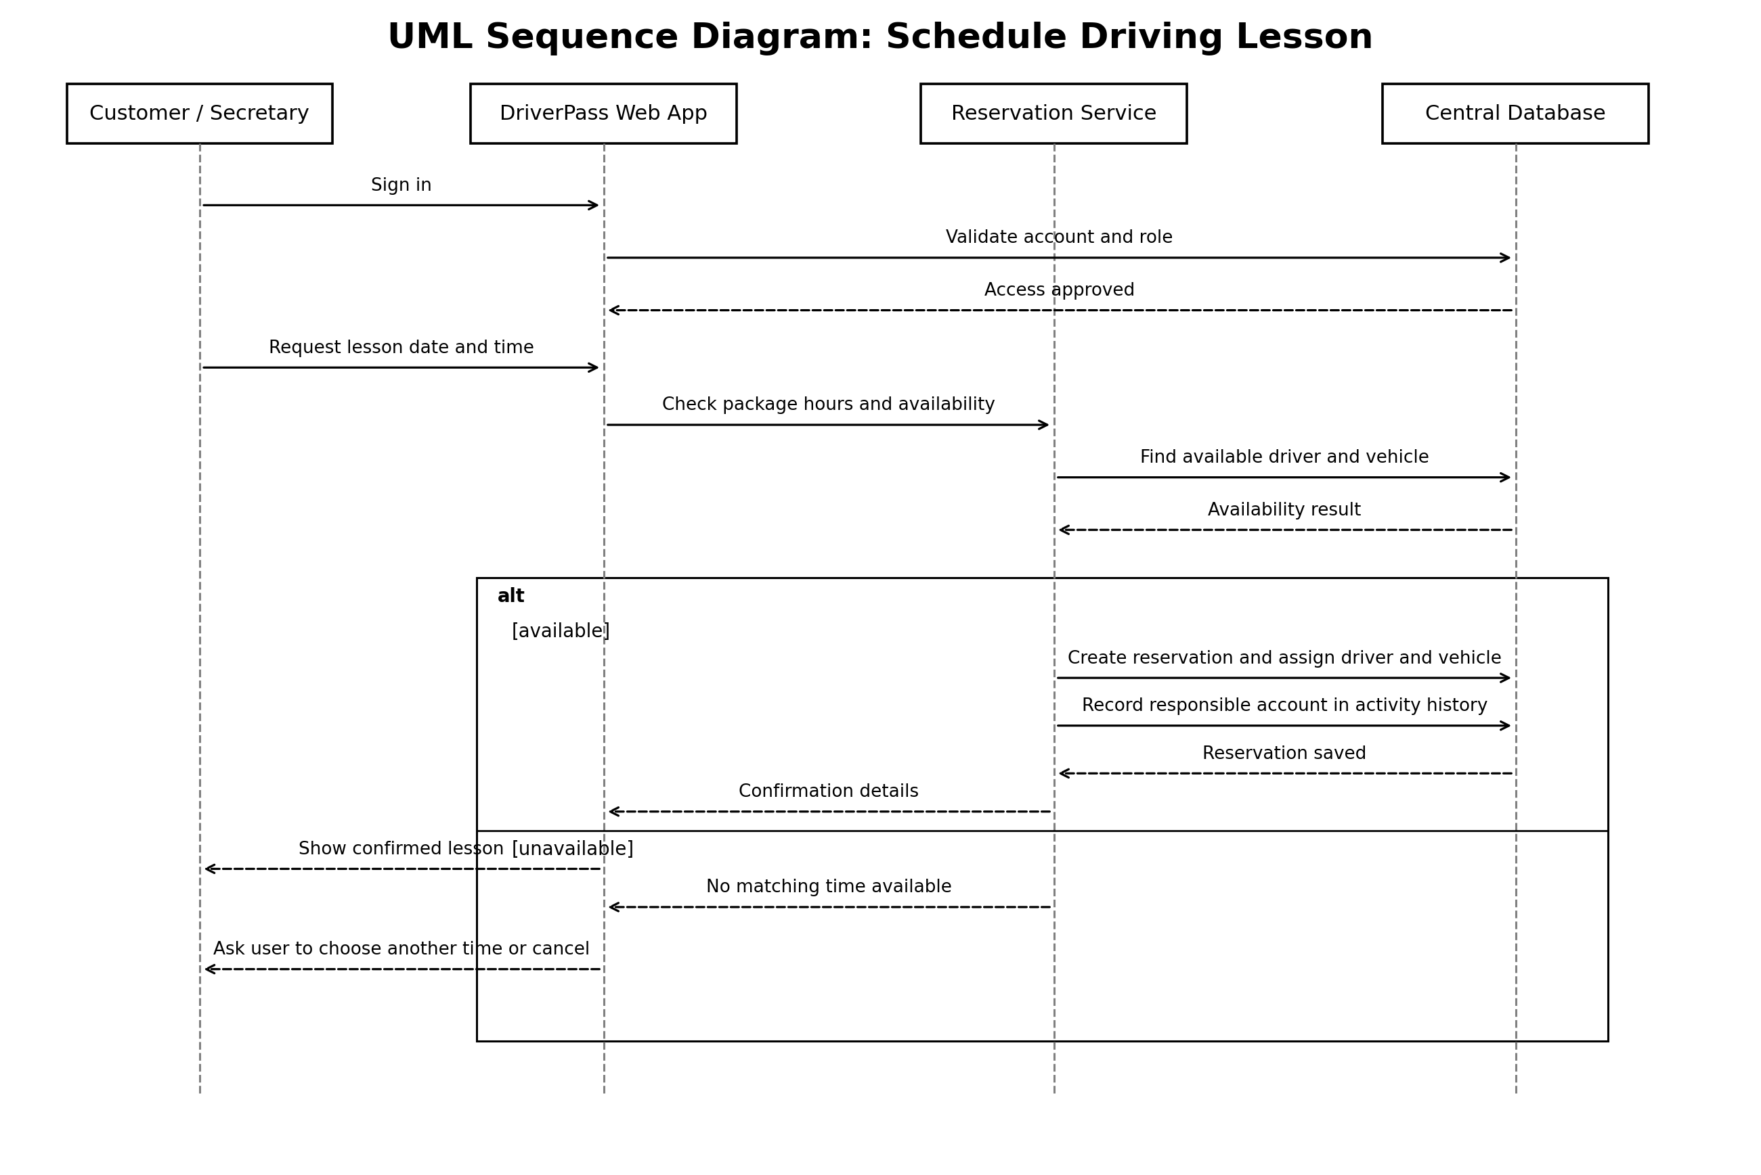
Figure 4. Schedule driving lesson sequence diagram.

UML Class Diagram
The class diagram organizes the main people, records, services, and resources described in the DriverPass requirements. The relationships connect customers to packages, reservations, tests, drivers, vehicles, notes, and activity history. Methods are not included because the Project Two template does not require them.
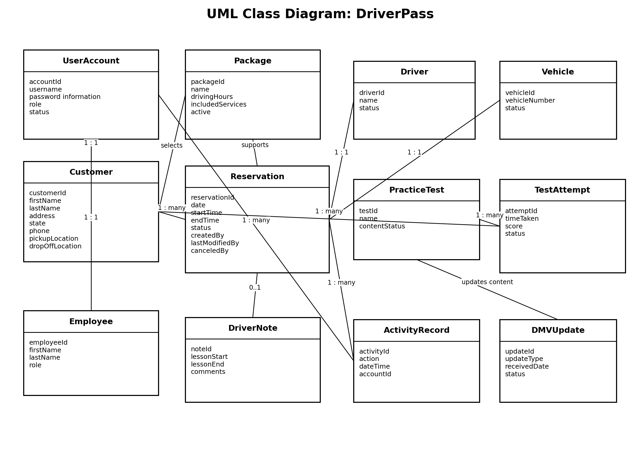
Figure 5. DriverPass UML class diagram.

Technical Requirements

Hardware
• Customers and employees need a computer or mobile device that can run a supported web browser.
• Users need a reliable internet connection to create or update live DriverPass records.
• The system needs cloud hosted computing, storage, and backup infrastructure. DriverPass does not want to maintain local servers for backup and security.

Software
• DriverPass needs a web based application that works through common desktop and mobile browsers rather than requiring one operating system.
• The application needs a centralized database for user accounts, customer records, packages, reservations, drivers, vehicles, test results, driver notes, and activity history.
• The system needs authentication and role based permissions for the owner, IT officer, secretary, driver, and customers.
• The system needs report download capability in a format that can be opened in Excel.
• The system needs a connection that can receive DMV notifications about updated rules, policies, or sample questions.

Security and Data Protection
• Protected information must require an authenticated account before it can be viewed.
• Data sent between the user and the cloud service must use an encrypted connection, and sensitive customer and payment information must be protected in storage.
• Failed login attempts need rate limiting or temporary account locking, with a security record and an IT officer alert when appropriate.
• Customers need automatic password reset, while the IT officer needs the ability to reset employee accounts and block access when needed.
• Reservation creation, cancellation, and modification must be recorded so DriverPass can identify the responsible account.

Tools and Infrastructure
• Lucidchart is used as the CASE tool for the UML models in this design.
• The deployed system needs a cloud hosting environment that provides backup, infrastructure security, availability monitoring, and centralized updates.
• The final development stack, cloud vendor, database product, payment service, exact browser list, and measurable response time targets are not defined in the interview. These choices must be confirmed during detailed design before development is finalized.

AI Use Disclosure
All thoughts and ideas are original and are from me. AI helps with my adhd to organize and proofread my thoughts based on the rubric and course materials. All work has been personally reviewed, written, and revised by me.

